Project Design Phase-II
Technology Stack (Architecture & Stack)

Date | 01 July 2026
Team ID
Project Name | Heritage Treasures: An In-Depth Analysis of UNESCO World Heritage Sites in Tableau
Maximum Marks | 4 Marks

Technical Architecture:
The Deliverable shall include the architectural diagram as below and the information as per the table1 & table 2
Example: Heritage Treasures: An In-Depth Analysis of UNESCO World Heritage Sites in Tableau
Reference: https://developer.ibm.com/patterns/ai-powered-backend-system-for-order-processing-during-pandemics/
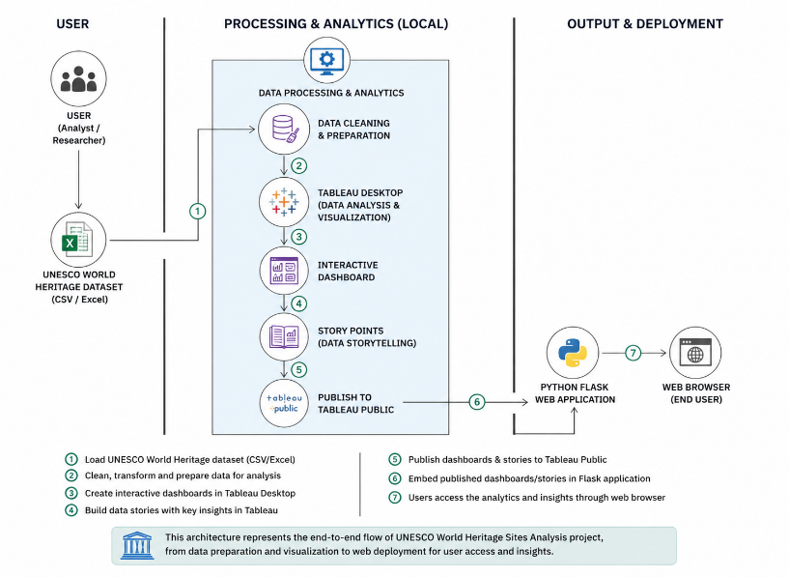
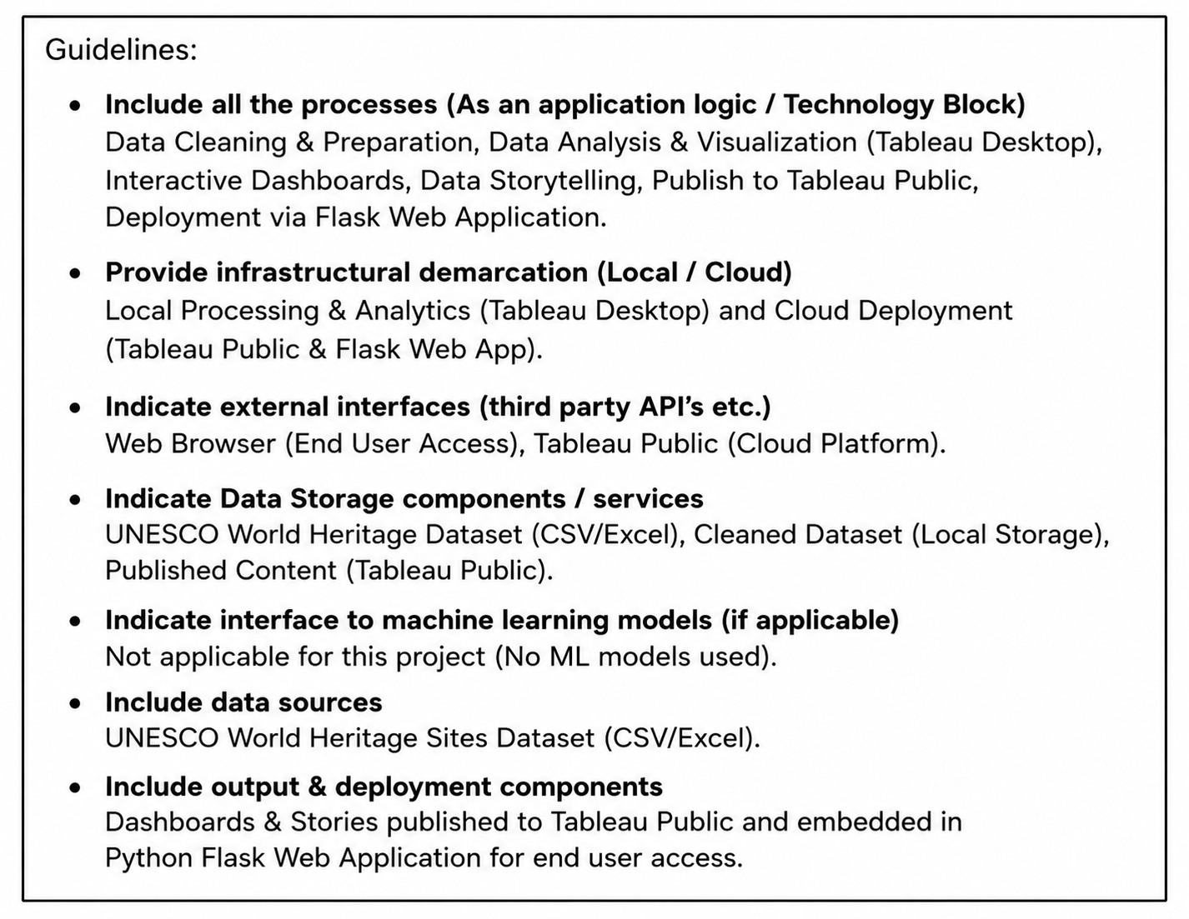

Table-1 : Components & Technologies:
S.No | Component | Description | Technology
 | User Interface | Provides an interactive web interface for users to explore UNESCO heritage dashboards and stories. | HTML5, CSS3, JavaScript.
 | Application Logic-1 | Loads UNESCO World Heritage dataset and performs preprocessing operations. | Python
 | Application Logic-2 | Performs data visualization and dashboard development. | Tableau Desktop
 | Application Logic-3 | Publishes dashboards and embeds Tableau Story into the web application. | Tableau Public, Python Flask
 | Database | Stores UNESCO world Heritage dataset locally in CSV format for analysis. | Excel sheet.
 | Cloud Database | Public cloud platform used to host published dashboards and stories. | Tableau Public Cloud.
 | File Storage | Stores dataset, images, HTML templates, CSS, JavaScript files, and project resources. | Local Filesystem.
 | External API-1 | Embeds published Tableau dashboards into the Flask web application. | Tableau JavaScript API.
 | External API-2 | Serves static images and project assets through Flask. | Flask Static File Handling.
 | Machine Learning Model | Forecasting future UNESCO Heritage trends using Tableau forecasting analytics. | Tableau Forecasting Model.
 | Infrastructure (Server / Cloud) | Hosts the Flask web application and serves embedded Tableau dashboards through a local web server. | Python Flask (Localhost), Tableau Public.

Table-2: Application Characteristics:
S. No | Characteristics | Description | Technology
 | Open-Source Frameworks | Frameworks and libraries used for web development and data processing. | Python Flask, Pandas, NumPy, HTML5, CSS3, JavaScript.
 | Security Implementations | Protects application resources and ensures secure communication between Flask application and Tableau Public. | Flask Routing, HTTPS (Tableau Public), Input Validation.
 | Scalable Architecture | Modular architecture separates data processing, visualization, and web interface, allowing future expansion. | Python Flask + Tableau Architecture.
 | Availability | Dashboards are published online and accessible through Tableau Public, while the web application is available locally or can be deployed online. | Tableau Public, Flask Web Server.
 | Performance | Optimized visualization and lightweight Flask application ensure fast loading and smooth interaction with dashboards. | Tableau Dashboard Optimization, Flask.

References:
https://c4model.com/
https://developer.ibm.com/patterns/online-order-processing-system-during-pandemic/
https://www.ibm.com/cloud/architecture
https://aws.amazon.com/architecture
https://medium.com/the-internal-startup/how-to-draw-useful-technical-architecture-diagrams-2d20c9fda90d

